National Professional Practice Examination (NPPE) Candidate Guide

NPPE participating associations

Table of Contents
Overview 3
Exam contact information 3
Study materials 3
Textbooks 4
Additional Free Study Materials 4
NPPE practice test site 4
Registration process 5
Testing accommodations 5
Test centre locations and virtual/remote proctoring 5
Confirmation email process for test centres and virtual/remote proctoring 6
Rescheduling, cancellations, refunds 6
Exam day process – Test Centre Locations 7
Exam day process – Virtual/Remote Proctoring 8
Exam security and exam irregularities 9
2020/2021 exam administration dates 10
Exam fees 10
Exam scoring and results 11

Overview

This NPPE Candidate Guide is the official guide to policies and procedures for the NPPE. All candidates are strongly encouraged to read this document before starting the exam registration process. It is your responsibility to make sure that you have the current version of this document.

The National Professional Practice Exam (NPPE) confirms knowledge of several content areas as outlined by the exam syllabus. Twelve engineering and geoscience self-regulatory organizations across Canada use the NPPE as one of their requirements for licensure.

To be eligible to take the NPPE, you must have submitted an application for professional membership (those who have not submitted an application to your provincial association for membership will not be allowed to register for the exam).

The exam is computer-based and is administered through Yardstick, a Canadian computer-based testing vendor. There are five exam administration sessions offered per year.

The exam format is 120 multiple choice questions, each with four options and only one correct answer per question. Ten questions are specifically directed to PEO applicants. All questions are scored 0 (incorrect) or 1 (correct) with no penalty for guessing. The time to take the exam is 3.0 hours.

Exam contact information

Questions regarding the NPPE should be directed to exams@peo.on.ca

Study materials

The exam syllabus/blueprint outlining the content areas that are covered on the exam can be found on the PEO website at: https://www.peo.on.ca/licence-applications/become-professional-engineer/professional-practice-exam

The syllabus/blueprint is a guide to help applicants determine what information they need to know and to bring to the exam in order to demonstrate their knowledge of the material. Although there are recommended study materials that are listed below applicants can gain mastery of the topics covered on the exam any way that works best for them.

Textbooks

Currently there are two textbooks (and additional study material listed below) recommended to prepare for the NPPE:

Canadian Professional Engineering and Geoscience: Practice & Ethics, Fifth or Sixth Edition, 2014/2018 by Gordon C. Andrews, Patricia Shaw, John McPhee

Practical Law of Architecture, Engineering, and Geoscience, Second or Third Canadian Edition, 2011/2015 by Brian M. Samuels and Doug R. Sanders

These textbooks can be purchased directly from the publishers, through online book retailers, or as part of a test preparation bundle that can be purchased from the NPPE practice test site.

Additional Free Study Materials

Below are free study materials that can be used to help prepare for the examination.

Professional Engineers Act
Regulation 941
Regulation 260/08
Professional Engineering Practice
Use of Seal
A Guide to Copyright
A Guide to Industrial Designs
A Guide to Patents
A Guide to Trademarks
Concepts of Professionalism
Guideline for Ethical Practice
Occupational Health and Safety Act
Royal Bank of Canada article – “The Soul of Professionalism”

NPPE practice test site

Practice tests created from previously administered NPPE questions, are available for optional purchase from the official NPPE practice test site: www.nppepractice.com

The NPPE practice tests offered through the website provide candidates preparing for the NPPE test questions to become familiar with the types of questions that will be asked on the actual NPPE.

All candidates that take the NPPE practice tests receive a detailed diagnostic report showing the syllabus areas of strength and weakness as well as a question-by-question level breakdown of which questions were answered correctly or incorrectly with rationales as to why the correct answer to each question is correct.

The practice tests are administered using the same computer-based testing platform as the actual NPPE ensuring that the testing interface and features are identical to the actual NPPE. This helps familiarize candidates with the look and feel of the NPPE to help reduce test anxiety. The practice test site provides a number of practice test resources for candidates preparing for the NPPE to help prepare to take the NPPE.

Registration process

Registering for the NPPE is done through the PEO portal. After signing in, chose the Pay Fees tab and click on Exam Registration.

Testing accommodations

Specific testing needs can be accommodated for those candidates who are taking the NPPE. Testing accommodations can include:

- extended testing time
- extra breaks
- reduced-distraction testing rooms
- larger font (available to all candidate in the stock exam interface)

Submit a request for testing accommodations during the registration process. Supporting documentation from a health care or education specialist (written within the last three years) is required outlining:

- details of the disability
- details why testing accommodations are needed for a computer-based exam based on the disability
- specifically, what accommodations are required due to the disability (e.g., one hour of extra time is required due to a visual impairment)

You must submit the testing accommodation request and supporting information before the registration deadline. If received after the registration deadline, your exam will be rescheduled to the next session.

Test centre locations and virtual/remote proctoring

Computer-based test centres to take the NPPE are located across Canada in every province and territory. As part of the registration process you will be asked to provide your preferred test centre location, and date/time to take the exam. Every effort is made to accommodate your preference on a first registered first accommodated basis. In some cases, due to space limitations or other factors your preferences may not be able to be accommodated but all candidates that register to take the exam in an administration window will be able to take the exam.

In cases where candidates would like to take the examination outside of Canada or in remote locations within Canada a virtual/remote proctoring option exists. Virtual proctoring is a process where candidates take the NPPE via a computer with a webcam and a high-speed internet connection where they are proctored (supervised) by a virtual proctor via their computer. Virtual proctoring is sometimes referred to as “remote”, “virtual”, or “online proctoring” and in the context of the NPPE these are all referring to the same process of a candidate taking the exam in their home or office being monitored by a proctor through the internet via webcam, audio, etc. Virtual proctoring is generally not offered in areas where a physical test centre is available, however, with the closing of test centres during the COVID-19 pandemic remote proctoring is being offered more widely to NPPE candidates. ProctorU is the remote proctoring company used for the exam, which Yardstick will mention in their email. For more information on virtual proctoring contact exams@peo.on.ca.

Confirmation email process for test centres and virtual/remote proctoring

Approximately three to four weeks prior to each exam administration date, you will receive a booking confirmation email from Yardstick with information regarding the exam location and confirming the exam date and time of the exam. It is important to check your spam folder to ensure that the email is not accidentally filed into your spam. Should you not receive an email with this confirmation information at least two weeks prior to the examination date you should contact Yardstick immediately and request that a booking confirmation email be resent to you: testingsupport@getyardstick.com

In the case of exams done remotely, where test centre locations are closed, candidates will be sent an email from Yardstick with instructions on how to book their remote exam date and time for the exam (based on availability). It is very important that candidates choose their time zone carefully, as booking yourself in an incorrect time zone can lead to your exam time being missed. Also, if your location changes at the last minute, you will need to update this information with Yardstick prior to your exam day and change your time zone if necessary. The virtual proctoring company used for these exams is called ProctorU.

Rescheduling, cancellations, credits

Candidates can cancel their registration up to 28 days prior to the exam administration date. For cancellations made in this time period the fee paid will be credited towards your next registration. Cancellations made within four weeks (28 days) of the exam administration date will not be credited towards the next registration, however this will not count as one of the three allowed attempts. PEO will consider exam deferrals (allowing a candidate to take the NPPE in the next session at no charge) within this four-week period in the event of a medical emergency or illness, death in the family, court appearance, or military duty. A deferral form can be requested by emailing exams@peo.on.ca. Appropriate supporting documentation such as a doctor’s note must be provided. Candidates that select not to write the NPPE on the administration date will be coded No Show and the payment submitted will be lost and future sittings will have to be paid again. No Shows will not count as one of the three allowed attempts.

Exam day process – Test Centre Locations

On exam day it is recommended to have a copy of your confirmation email sent by Yardstick to take with you to the exam (whether on your phone or printed), as well as a piece of valid (non-expired) government issued photo ID. If your ID is expired you will not be permitted to take the exam and you will need to re-pay and re-register for the next examination session. The first and last name on your confirmation email and your ID must match exactly. If it does not you may not be permitted to take the NPPE. If you know in advance that the first and last name on your ID does not match the first and last name on your confirmation email you should contact Yardstick support immediately to let them know: testingsupport@getyardstick.com

Please read the booking confirmation email from Yardstick carefully as it specifies items that will be allowed or not allowed into the test centre (For example you may bring a clear water bottle, you cannot bring in a pencil or paper). Do not arrive late to the exam or you will not be admitted into the exam room. If you require any information about parking or directions ahead of time, please contact Yardstick, their contact information will be in the confirmation email you receive from them.

Once you have been admitted to the testing room and have been seated at your assigned computer the proctor will read instructions to you regarding the exam. Once the instructions have been read you will be able to start the exam and will take the exam using the test taking interface.

The Yardstick exam testing interface for the NPPE is designed to be highly intuitive and provides tools (e.g., bookmarking questions, writing notes on questions, ability to increase or decrease the font size, etc.) to assist candidates in taking the exam. Candidates who register for the NPPE will have free access several weeks prior to the exam administration date to become familiar with the NPPE test taking interface. A screenshot of the NPPE exam interface is shown below.

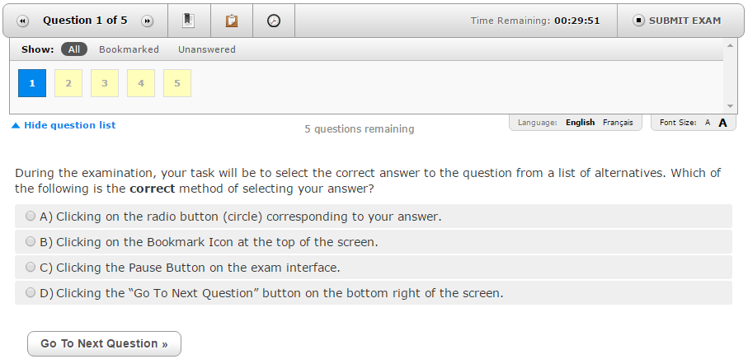

Once you have completed the NPPE on exam day you will be prompted to complete a short survey where you will be able to provide feedback on your exam experience.

Exam day process – Virtual/Remote Proctoring

Candidates will receive a confirmation email from Yardstick that explains the virtual exam process and the steps they should take on exam day. It is important to run all the computer checks that are suggested, and to ensure that all the computer requirements are met, including having a webcam (anything other than a webcam, such as a cellphone, is unacceptable). The ProctorU exam program cannot be downloaded until the day of your exam so there is no way to check if it will work prior to exam day. There is a short video tutorial that may be helpful, that you can watch through the Yardstick FAQ page here https://www.getyardstick.com/online-proctoring-faq/. It is best to take the exam in your home, as taking the exam at work requires having IT support staff on hand to ensure that the program is not blocked by a firewall.
It is also very important to note that candidates have a 15-minute window to log on to the ProctorU program, or the exam will be cancelled. Due to the high internet usage currently occurring, connecting to the virtual proctor may take up to 30 minutes after candidates log on. Only click the link once. Do not log off and log back in if you do not connect right away or exit out of the browser, as this will be viewed by the virtual proctor as the exam session being cancelled. Think of this process as boarding a plane and then sitting and waiting for the plane to take off. Just as you would not get off the plane, do not log out of your connection to ProctorU, just wait for the proctor to connect. It is completely ok if this connection time bypasses your exam start time, as long as your initial connection is still open. If technical issues occur trying to connect to your exam or during your exam, you must contact ProctorU as soon as possible. If you cannot reach them, contact Yardstick. Their contact information will be in your booking confirmation email, it is best to call for an immediate response. You are allowed one optional washroom break during the exam, and the exam timer will not stop during this break. This washroom break will be noted by the virtual proctor. If you require multiple bathroom breaks due to a medical issue, please let your association know when you register for the exam, and it will be noted as a testing accommodation. If there are technical issues out of your control that prevent you from taking your exam, a rebooking option may be available to you, depending on availability. This would be a last resort option if all other appropriate steps were taken.

Exam security and exam irregularities

The following situations may prompt the consideration of invalidating or canceling exam results even though you may have had no responsibility for the event in question:
- Unanticipated cancellation or interruption of testing or deviation from required testing procedures, due to a weather event or other external cause
- Possible advance access to exam content by one or more candidates
- Other disruptions or compromises to the normal testing process

If it is concluded that corrective action is warranted in one of these situations, you may be offered the option to either retest at no additional fee or to receive a full or partial refund of your registration fee provided that you did not cause and were not involved in the conduct that resulted in corrective action. These remedies are your exclusive remedies for such disruptions in testing and potential compromises. If you choose to retest, you must retake the entire exam to produce valid exam results. If you are found to have caused or been involved in the conduct that resulted in corrective action, the matter may be treated as an exam irregularity and all available remedies may be pursued as described elsewhere in this guide.

Fraud, deceit, dishonesty, unprofessional behavior, and other irregular behavior in connection with taking the NPPE are strictly prohibited. Irregular behavior includes but is not limited to the following: failing to work independently; impersonating another individual or permitting such impersonation (surrogate testing); possessing prohibited items; communicating with other examinees or any outside parties by way of cell phone, personal computer, the Internet, or any other means during an exam; disrupting other examinees; creating safety concerns; and possessing, reproducing, or disclosing nonpublic exam questions, answers, or other information regarding the content of the exam before, during, or after the exam administration. Evidence of an exam irregularity may be based on your performance on the exam, a report from an administrator or a third party, or other information. The proctor is authorized to take appropriate action to investigate, stop, or correct any observed or suspected irregular behavior, including discharging you from the test center and confiscating any prohibited devices or materials. You must cooperate fully in any investigation of a suspected irregularity. PEO reserves the right to pursue all available remedies for exam irregularities, including canceling scores and pursuing administrative, civil, and/or criminal remedies. If you are involved in an exam irregularity, the following may occur: invalidation of results, forfeiture of exam fees, and restrictions on future testing. Some violations may incur additional consequences, to be pursued at the discretion of PEO.

Collusion detection analysis is performed after each exam administration to statistically identify pairs of candidates that may have copied answers. Candidates that are flagged as potentially having colluded will have their examination results withheld pending an investigation into the matter.

Applicants and Professional Members are obligated to report any test security issues they are aware of, whether they occurred before, during or after the exam. Incidents can be reported anonymously to examsecurity@apega.ca.

All candidates must read and digitally sign a candidate statement of understanding prior to taking the NPPE which outlines the expectations and rules for taking the exam.

2020/2021 exam administration dates

The 2020 NPPE administration dates are listed below.

Exam Dates | Registration Deadline
September 14-16, 2020 | July 17, 2020
November 23-25, 2020 | October 9, 2020

The 2021 NPPE administration dates are listed below.

Exam Dates | Registration Deadline
January 25-27, 2021 | December 11, 2020
April 12-14, 2021 | February 26, 2021
June 14-16, 2021 | May 7, 2021
August 30-September 1, 2021 | July 16, 2021
November 8-10, 2021 | October 1, 2021

Exam fees
The fee in 2020 for the NPPE is $200. Additional fees may be charged for special accommodations. NPPE fees will increase annually.

Exam scoring and results

The NPPE conforms to all standards for psychometrically defensible high stakes testing as outlined in the “Standards for Educational and Psychological Testing”.

The NPPE is a criterion-referenced examination and so only pass/fail results will be reported. If you passed the exam, you will not receive detailed score information, only that you passed the exam. Exam results are either pass or fail based on the number of correct answers (1 point per correct answer) you achieved on the operational (scored) questions on the exam. You are not penalized for incorrect answers. The cut score on the NPPE is a scaled score of 65 and determined using a best practice Standard Setting approach (i.e., the Modified-Angoff Method) where Subject Matter Experts from across Canada participate in setting the minimum standard required (i.e., minimum level of knowledge) for candidates to be able to demonstrate on the exam in order to pass. Candidates should come to the NPPE ready to demonstrate their knowledge of all of the syllabus/blueprint areas. Statistical equating is used to ensure that variations in exam difficulty from each session are taken into account to ensure fairness to all applicants taking an exam. ETS, one of the largest and well respected testing organizations in the world, has published a report that explains test equating in more detail: https://www.ets.org/Media/Research/pdf/RR-10-29.pdf

Each NPPE is scored with no predetermined percentage of candidates that should pass or fail. All exams are scored the same way. First-time takers and repeat takers are graded to the same standard.

All exams include a limited number of experimental items that are not scored and will not have an impact on your results. Including experimental unscored questions on exams is common practice in high-stakes testing and allows for the evaluation of the experimental items for potential use in future exams. These items are placed within the exam and are not identifiable as experimental questions.

Exam results are usually available approximately 2-3 weeks after the exam administration date and always prior to the next registration deadline date. Results are not provided over the phone or by email. Candidates that failed the exam are sent a mastery report which outlines the content areas of the exam where the candidate did well and areas where the candidate did not do well and should focus further study. An example mastery report is shown below.

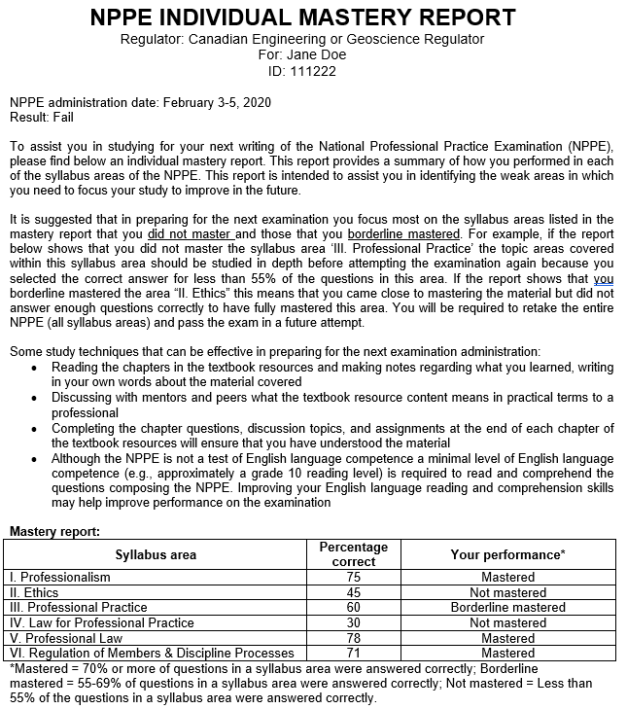

PEO allows candidates three attempts to pass the NPPE.

