Newsletter # 2025-1:
Licensure Presentation Ceremony (LPC) – November 15, 2024
Willowdale/Thornhill Chapter, PEO
The Willowdale/Thornhill Chapter of Professional Engineers Ontario (PEO) successfully hosted its second Licensure Presentation Ceremony (LPC) of 2024 on November 15, 2024, at the Thornhill Club. The event celebrated newly licensed engineers and brought together industry professionals, family, and friends in an evening of recognition and networking.
Event Highlights
- Guest of Honor: Mr. Vincent Ko, MPP for Don Valley North, addressed the attendees, emphasizing the role of professional engineers in shaping Ontario’s future.
- License Recipients: A total of 38 newly licensed engineers were invited, with 32 attending in person.
- Guests & Entertainment: The ceremony saw a turnout of 98 guests, and the evening was further enriched by a live saxophone performance by Mr. Hector during dinner.
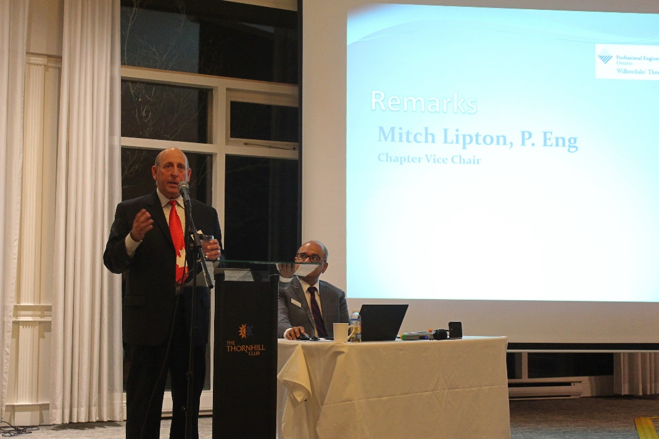
Picture 1: Mitch Lipton, P.Eng, (Chapter Vice Chair) Opening remarks.

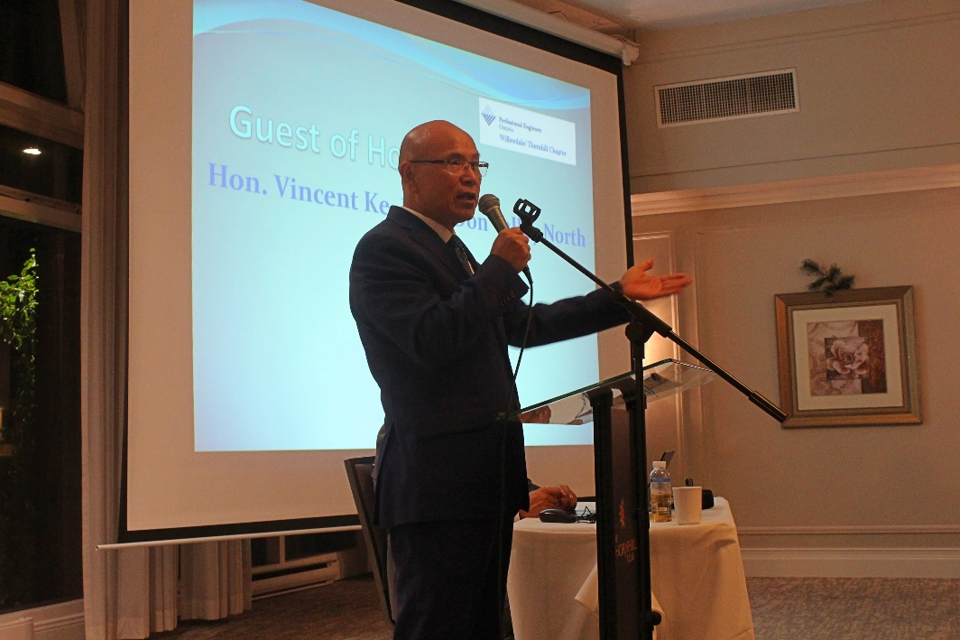
Picture 2 – Mr. Vincent Ko (Guest of Honor) addressing the attendees.
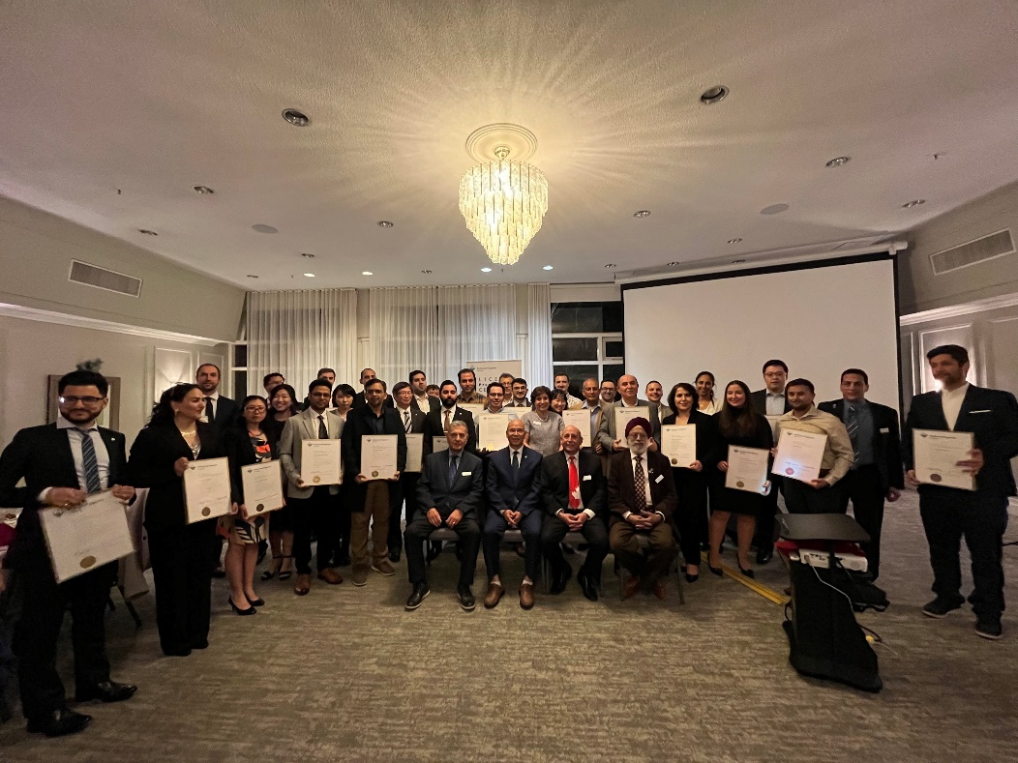
Picture 3 – Licensees with the Guest of Honor & Senior Board members
We extend our gratitude to all organizers, volunteers, and attendees who made this event a success.
Stay tuned for our next chapter event!

