**2023-2024 Annual General Meeting**

**Year in Review**

**12 March 2024**

1. Meeting Agenda

* 6:00 - 6:30 PM Networking and Welcoming Participants
* 6:30 - 6:45 PM Opening Remarks and Introduction
* 6:45 - 6:50 PM Call to Order, Approval of Agenda 2024, and Minutes of 2023 AGM
* 6:50 - 7:05 PM Committee Chairs Reports
* 7:05 - 7:15 PM Speech by Mr. Dan Abrahams, VP, Policy & Governance, and CLO
* 7:15 - 7:30 PM Nomination Committee Chair to Explain Election Process
* 7:30 - 8:00 PM Introductions by Candidates
* 8:00 - 8:30 PM Voting of Slate of Candidates
* 8:30 - 8:45 PM Announcement of 2023 Executives
* 8:45 - 9:00 PM Adjournment Networking

1. Call to order at 6:39PM.
2. Work remarks and introduction to Mr. Dan Abrahamson.
3. Board Members were introduced.

Mitch Lipton, P.Eng. Chair

Farzaneh Omrani, P.Eng. Vice Chair

Amit Gupta, P.Eng. Treasurer

Karen Penaranda, EIT. Secretary & Education

Debasis Dey, P.Eng. AGM & LPC

Mohinder Grover, Ph.D. P.Eng., FEC, FEIC Awards

Bo Dang, P.Eng. EIT, LAP

Ekaterina Shilina, EIT Electronic Media

Fred Saghezchi, P.Eng. GLP

Karen Miller, EIT GLP

Nabil Ghariani, P.Eng. PTOE, M.S.C.E., M.Ed. Programs

Atena Mahiny, P.Eng. Networking Chair

John Penaranda, P.Eng., FEC Past Chair

Noubar Takessian, P.Eng., FEC Executive

Mammad Horriyat, P.Eng., FEC Executive

Souheila Bardakji, Ph.D. P.Eng., FEC Executive

Shayan Sepiani, PhD., P. Eng., Executive

1. Mitch was requested.
2. Meeting agenda was approved by John Penaranda P.Eng. and Farzaneh Omrani P.Eng.
3. Minutes were approved by Amit Gupta P.Eng. and Noubar Takessian P.Eng.
4. Remarks by Chair: Chair Report: AGM + LPC by Debasis Dey P.Eng.

* In 2023, AGM was held at Edithvale Community Centre on March 7th.
* In 2023 -24, Two LPC events were organized. Details of LPC event as follows:

|  |  |  |  |
| --- | --- | --- | --- |
|  | **LPC Event Details** | **Event 1** | **Event II** |
| 1 | Date of Event | July 26th, 2023 | Jan 26th, 2024 |
| 2 | Place of Event | Thornhill Club | Thornhill Club |
| 3 | Total No of License Recipient invited (attended) | 42 (33) | 34 (26) |
| 4 | Total No of Guest Attended | 114 | 88 |
| 5 | Guest of Honour -MPP | Ms. Laura Smith, MPP Thornhill | Mr. Vincent Ke, MPP Don Valley North |
| 6 | Guest Speakers | 1. Paul Acchione, Former Chair, OSPE  2. Christopher Chahine, PEO Vice-President | 1. Roydon Fraser, PEO President 2. Christopher Chahine, PEO Vice-President |
| 7 | Cost of the event | $ 13, 816.27 /- | $ 11, 503.82 /- |

1. Awards by Mohinder Grover, P.Eng.

**Background: PEO recognizes or supports recognition of Professional Engineers and Volunteers for their:**

Engineering Excellence, Service to Profession, Service to PEO, and Service to Public / Society.

As engineering regulator in Ontario, PEO relies heavily on its volunteers. More than 700 professional engineers, engineering interns and non-engineers volunteer their time each year on behalf of the regulator through their participation. And, to encourage on-going volunteerism, PEO considers it to be very important to recognize deserving volunteers for their contributions.

**Committee’s Mandate:**

Search for deserving Chapter members and encourage nominations for several different internal (PEO) and external awards.

* Order of Honour (Member, Officer, Companion)
* Fellow, Engineers Canada (FEC)
* PEO Volunteer Service Recognition Program (Achievement of service milestone)
* National Volunteer Week (In the month of April))
* Chapter specific Volunteer Service Recognition
* Ontario Volunteer Service
* OSPE Ontario Professional Engineering Awards (OPEA) – Gold Medal, Engineering Medal, Citizenship Award, Award for Engineering Project or Achievement (Public Service, Technical Excellence, Leadership, Quality of Life)

**Awards received by Chapter members in 2023.**

* Bo Dang; P. Eng. (Certificate & 5-year service Pin)
* Mohinder Grover, P. Eng. (Certificate & 25-year service Pin)

1. Education Committee by Karen Penaranda EIT.

Event: TinkerCad

We will teach aspiring engineering elementary students to use TinkerCad.

Education Scholarship

We will launch the academic scholarships in March.

Camp Engies

We sponsor 11 young ladies to go to a 2 day engineering camp.

Photonics Learning Experience

We had an Event at Activate Scarborough to learn about photonics and puzzles.

1. EIT and LAP by Bo Dang P.Eng.

Round 11 of LAP (Jan-June 2023)

Kick Start Session (meet and greet)

LAP Mentor Appreciation Dinner

Note:

Pre-May 15th 2023 applicant may remain in the EIT program

New Applicant: Post May 15th 2023 Applicants required to record experience using the new CBA system (July 1, 2023 online application portal launched)

1. Electronic Media by Ekaterina Shilina P.Eng.

* The committee is responsible for communicating all relevant chapter business with chapter members. Communication with members is accomplished through the use of email and webpage updates.
* The Electronic Media committee is tasked with the following activities:  
   - Maintaining and providing updates to the website including hosting, payments and forwarding emails for the board members  
  - Creating new sections on the website such as "Blog" etc.  
  - Documenting, photographing and archiving chapter business  
  - Distribution of chapter events and notifications using Campaigner and social media platforms such as Facebook, LinkedIn, etc.  
  - Maintaining the chapter's monthly board meeting and events through the Zoom platform, creating links and rendering technical support to all board members.

1. GLP by Fred Saghezchi P.Eng.

* Meeting with MPP Laura Smith in her office, April 21, 2023
* Conversation about activities of PEO
* Invitation for upcoming License Presentation Certificate ceremony
* Introduction of new GLP chair, Fred Saghezchi by chapter chair
* Making arrangements and accommodating MPP Laura Smith and her assistant in LPC ceremony on May 26, 2023
* Participation of all GLP team members in GLP Summit on November 18, 2023
* Meeting with MPP Vincent Ke in his office
* Introduction of new GLP chair, Fred Saghezchi by Nanda Lwin, East Central Region Councilor
* Invitation to upcoming LPC ceremony
* Receiving an appreciation letter from MPP Vincent Ke on January 18, 2024
* Making arrangements and accommodating MPP Vincent Ke and his assistant in LPC ceremony on January 26, 2024
* Preparation of a report about GLP Summit and other MPP involvement activities for chapter media on December 06, 2023.
* Completing GLP Training for all GLP volunteers (Mandatory)
* Including webinars, online test, Studying GLP manual, etc.

ONGOING ACTIVITIES

* Making arrangements for the program “Take Your MPP to Work”. It will be launched in 2024. An MPP will be invited to visit an engineering company.
* Communicating with Minister Stan Cho for upcoming events

1. Programs by Nabil Ghariani, P.Eng.

[Dave to send this]

1. Publications had no update.
2. Treasurer report by Amit Gupta P.Eng.

Prepare and assist chapter annual business plan.

Approve and keep track of chapter expense in Certify.

Financial feasibility and management

* Appointed Treasurer August 2023
* 2023 Actual spend $42368.75.
* 2024 approved budget $58865.00 (Ask $62940)
* Business plan below.

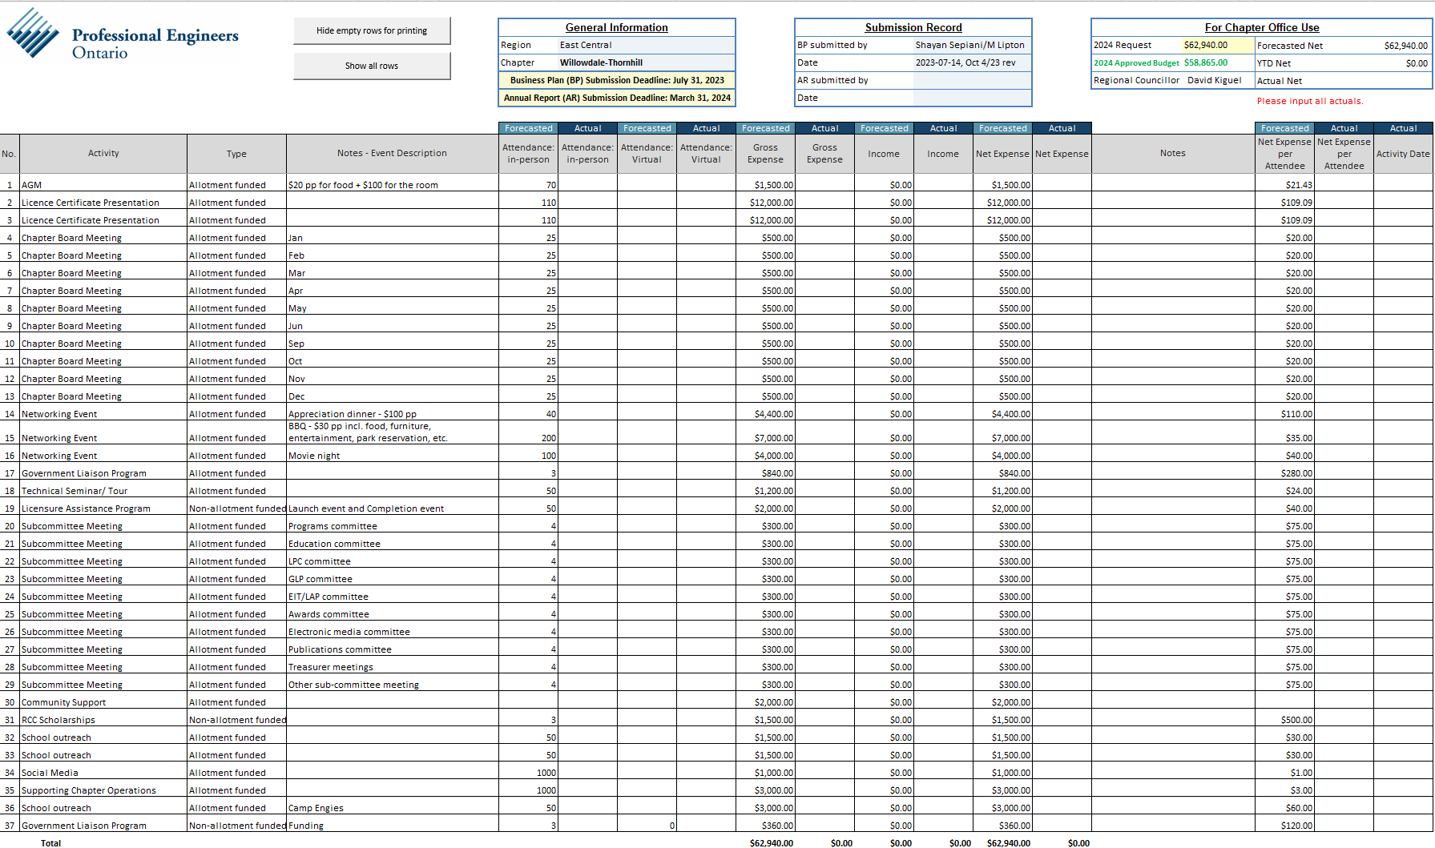

1. Remarks by Mr. Dan Abrahams, VP, Policy & Governance, CLO, PEO

* Mr. Dan Abrahams worked 16 years as a Senior Counsel and Manager at the Law Society of Ontario and, before that, 8 years as a lawyer and mediator at an administrative tribunal.
* Dan joined the staff of PEO in 2019.  As a member of PEO’s Executive Leadership Team, Dan is responsibility for policy development, the Secretariat (including Council operations), external and stakeholder relations, communications, practice advisory and the PEAK mandatory continuing professional development initiative.
* Dan’s group also supports the work of PEO’s two statutory tribunals, the Discipline Committee, and the Registration Committee.
* Dan is a graduate of the University of Toronto and the Faculty of Law of the University of Windsor.  He is a former law clerk to the justice of the Ontario Court of Appeal, the province’s highest court.  Dan was called to the bar of Ontario in 1991.

1. Nomination Committee by John Penaranda P.Eng. and Noubar Takessian P.Eng. Slate of candidates. This was approved by all board members.

* Farhad (Fred) Saghezchi, P.Eng.
* Souheila Bardakji, P.Eng.
* John Penaranda, P.Eng.
* Mitch Lipton, P.Eng.
* Karen Penaranda Valdivia, EIT
* Noubar Takessian, P.Eng.
* Mohammad Horriyat, P.Eng.
* Mohinder Grover, P.Eng.
* Bo Dang, P.Eng.
* Amit Gupta, P.Eng.
* Nazanin (Farzaneh) Omrani, P.Eng.
* Nabil Ghariani, P.Eng.
* Ekaterina (Kate) Shilina, EIT
* Debasis (David) Dey, P.Eng.
* The new chapter executive will meet on April 09, 2024.
* The current chapter board will be dissolved at that meeting.
* The new chapter board will nominate and elect new officers for 2024-2025.

1. Other business by Mitch Lipton, P.Eng.
2. Meeting adjourned by Noubar Takessian P.Eng. and Mohammad Horriyat P.Eng. at 7:56 PM.